Carl Andrew Perkins
4/7/2019

Questions For Investigation
1. What is our independent variable? What is our dependent variable?

The dependent variable in this test is number of seconds it takes to complete the task. Since there are two listings in this Stroop task, both congruent and incongruent word conditions, the independent variable is different types of word conditions themselves.

2. What is an appropriate set of hypotheses for this task? What kind of statistical test do you expect to perform? Justify your choices.

Things to note are we are assuming a normal distribution. Also the sample size is less than 30 (24) so we can also assume a small sample size. The variance of the populations also seems to be unknown.

An appropriate set of hypotheses for this task is as follows:

- H0: μc−μi>=0
- Ha: μc−μi<0

The null hypothesis implies that if H0 is true that the incongruent word conditions time would not be significantly longer than the congruent word conditions time. The alternative hypothesis Ha would imply that the incongruent condition would indeed take much longer time than the congruent word condition. μc is the congruent average of times while μi is the incongruent average of times. The statistical test I expect to perform is a sample T-test. Based upon my own hypothesis, I predict that the incongruent time will take much longer than the congruent variable test.

3. Report some descriptive statistics regarding this dataset. Include at least one measure of central tendency and at least one measure of variability.

The first column is used for statistical headers for measurements and is located at the bottom in bold. The second column measures the time that it takes for an individual to complete the test using the congruent variable. The third column reflects the time in seconds that it had taken an individual to perform the task using the incongruent variable. The outputs below have been performed using excel functions.

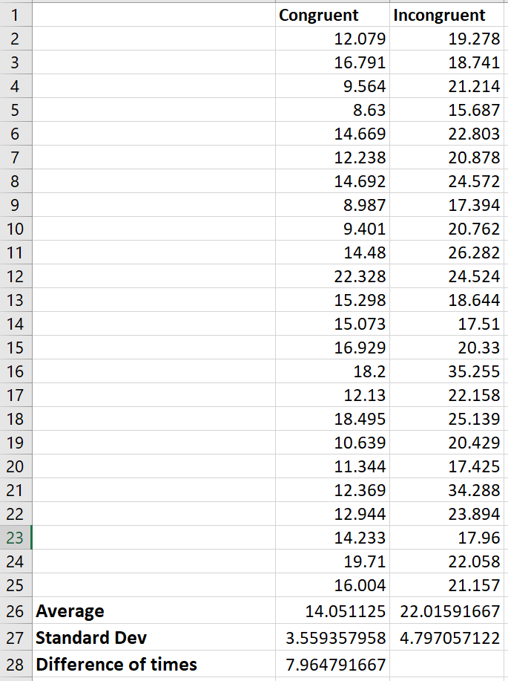

4. Provide one or two visualizations that show the distribution of the sample data. Write one or two sentences noting what you observe about the plot or plots.

The below line plot as well as the bar chart both show that the incongruent data remained consistently longer that the congruent data testing.

5. Now, perform the statistical test and report your results. What is your confidence level and your critical statistic value? Do you reject the null hypothesis or fail to reject it? Come to a conclusion in terms of the experiment task. Did the results match up with your expectations?

The below is the result of the performed T-Test for means while using the confidence level of 95% using excel functions and the data analysis add-in.

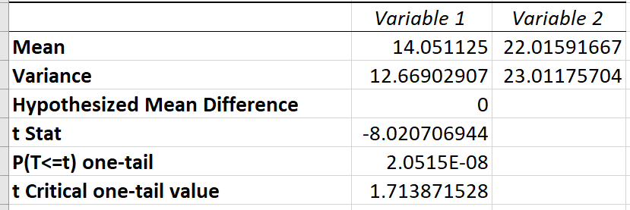

Based upon the test ran above we reject the null hypothesis H0. The P value is less than our confidence level of .05 and is close to zero. Also because the T-value we embrace the alternative hypothesis Ha and can conclude that it takes much longer for the incongruent variable times. This subsequently matches my original hypothesis.

6. Optional: What do you think is responsible for the effects observed? Can you think of an alternative or similar task that would result in a similar effect? Some research about the problem will be helpful for thinking about these two questions!

Most likely the biggest contributing factor for the results are that we are trained in school to read words in stead of colors.

Note: I did not use or refer to any material in the use and execution of this project. I had previous experience with statistics, and I used excel to run my calculations, statistics and visualizations.

